EXPT NO :1 Build a LAN topology in Cisco Packet Tracer
Objectives:
(iii) To implement a hybrid topology using Packet Tracer and hence to transmit data between the devices connected using a tree topology.
Software/Apparatus required:
(i) Cisco Packet Tracer
(ii) End Devices (PCs)
(iii) Switches
(iv) Copper Straight-through Cable / Automatic Cable Selector
Procedure :
Step 1: Start Packet Tracer
- Launch Cisco Packet Tracer.
Step 2: Select Devices
- Choose the required end devices (PCs).
- Select the required networking devices (Switch, Hub, or Bridge) according to the topology.
Step 3: Build the Network Topology
- Drag and place the required PCs and networking devices into the workspace.
- Arrange the devices according to the specified topology (Star, Mesh, Hybrid, etc.).
Step 4: Connect the Devices
- Select the appropriate cable (Copper Straight-through or Automatic).
- Connect each PC to the corresponding networking device.

- Wait until the interface status changes from amber to green after the STP initialization process.
Step 5: Configure IP Addressing
- Open each PC.
- Navigate to Desktop, IP Configuration (or Config, FastEthernet0).
- Assign the IP address.
- Configure the subnet mask (or allow Packet Tracer to generate it automatically).
Step 6: Verify Connectivity
- Open Desktop and then Command Prompt.
- Use the ping command to test communication between devices.
- Alternatively, use Add Simple PDU in Realtime or Simulation mode to verify packet transmission.
- Confirm successful communication through ping replies or successful PDU status.
Networking Diagram:
Objective (iii): Implementation of Hybrid Topology
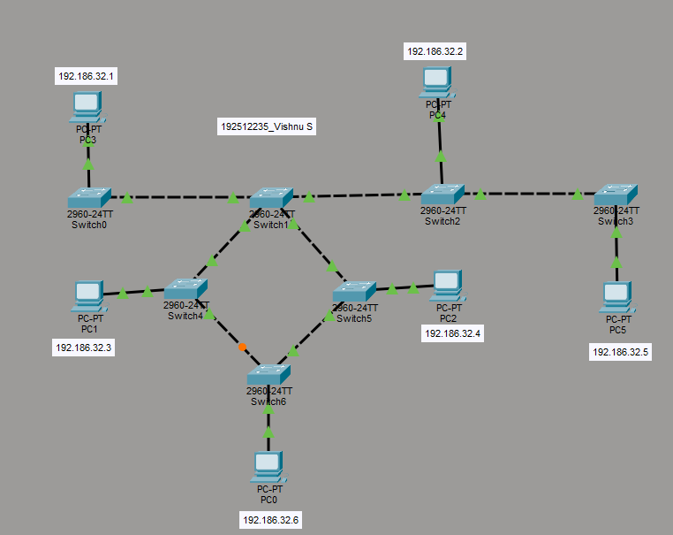

Output:
Objective (iii): Implementation of Mesh topology
Sl. No | Source IP | Destination IP | Data sent (bytes) | Data received (bytes)
1 | 192.186.32.6 | 192.186.32.4 | 4 | 4
2 | 192.186.32.3 | 192.186.32.6 | 4 | 4
3 | 192.186.32.4 | 192.186.32.3 | 4 | 4
4 | 192.186.32.5 | 192.186.32.2 | 4 | 4
5 | 192.186.32.7 | 192.186.32.3 | 4 | 4
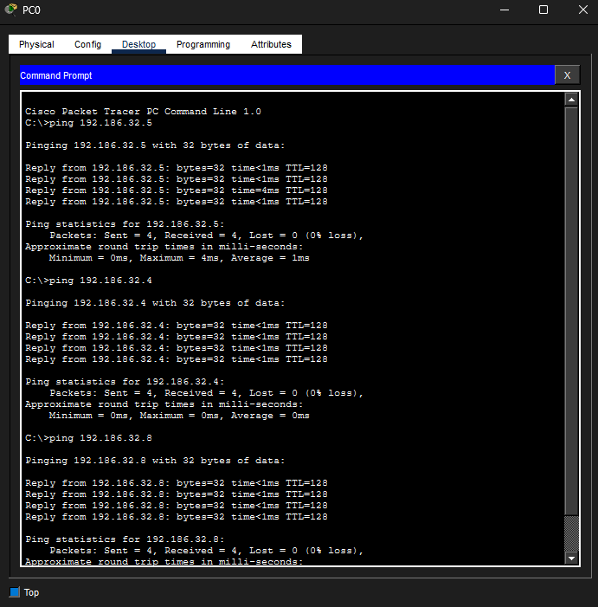

Result:
Objective (iii): Implementation of Hybrid Topology
The Hybrid (Bus–Ring) topology was successfully established in Cisco Packet Tracer, and successful network connectivity between the connected devices was achieved.

